Functional Specification
Document Name: FS-Process Step-Name of the Title for this FS document
Process Step: Process Step, Name of Process Step
Title: Name of the Title for this FS document
Approval

Change History
All italic and blue text in this document is for descriptive purposes only.
Note by: before finishing and storing the document all reference field in the document should be updated and refreshed. This can be done individually by navigation to the reference field and pressing key “F9” or by selecting the page preview functionality and switching back to normal edit mode. The table of contents has to be updated individually itself and will not be effected by the page preview mode.

Version | Author | Description of Change
01 | Ingo Kaulbach  (EVFPU) | Initial Creation, ZHHR:
Table of Contents
1 Overview 4
2 Scope Description 4
3 Terms and Definitions 4
4 Cross References 4
5 Functional Realization Statements 5
5.1 Reference to Configuration Documents / Customizing Objects 19
6 Attachments 20
7 Further Information 20

Overview
Please provide an overview of the functional realization of the user requirements from the URS. Briefly summarize the overall functional realization of the process step in SAP.
The Menu Path column could be left empty when such a menu path is not available
Also this information should be given in free text form below the table:

This is a Functional Description for process-step - .
SAP Easy access menu to the main transactions is been described in the following table:
Menu Path | Transaction Code
N/A | N/A

Scope Description
The scope is the same as defined in the URS document, so only a reference is given.
It defines the applicable specification from a global or local point of view.

For the description of the scope please see the URS related to this process step:
URS-- UPDATE WHEN KNOWN

Terms and Definitions
Please make sure, that all terms, definitions, abbreviations and acronyms that may be helpful for understanding this document are listed. You may add some very specific terms and definitions to the table below. Otherwise please fill in “N/A”.

Term | Definition
N/A | N/A

Cross References
Please list all related process steps, Customizing Objects and other Functional Specifications
- Only list Business Processes / Process Steps where this FS is explicitly referenced in a realization statement in the FS for that process step. Do NOT list process steps which are just loosely connected to this development
- Also list other developments which may be related to this document.

Related Business / Process Steps | N/A
Related Functional Specifications | FS-Doc41 Web UI - UserManagement.doc
Related Design Specifications | DS-Doc41 Web UI.doc

Functional Realization Statements
Please translate each user requirement statement from the URS into functional realization statements in the table below. Please therefore indicate the corresponding requirement number from the URS and the type of realization (S, C, D, A, SOP, M, N.).
- For traceability reasons every realization statement must get a unique ID (column “Realization ID”). Naming convention: XX_XX_XX_FS_NNN
  - XX_XX_XX: ID of the Process Step, e.g. M-220-010
  - NNN: up counting number of the realization statement
- The requirement IDs could be referenced in an abbreviated manner (column “Requirement ID”), e.g. as GR_001, if they refer to the same process step Process Step
- Please use one line for one realization statement
- The type of realization defines in short how the requirement is realized (column “Type”):
  - S: The requirement is realized by SAP standard, no customizing or whatsoever required (Transaction Codes must be filled in column “Realization Statement”).
  - C: Customizing is necessary (Transaction Codes and Customizing Objects must be filled in column “Realization Statement”). Realized by a custom made development (Customizing Objects and references to Design Specification must be filled in column “Realization Statement”).
  - A: Realized by the Authorization Setup
  - SOP: not technically realized, instead a procedure is created
  - M: the requirement can be fulfilled by master data maintenance.
  - N: not realized at all.
- If one realization statement covers more than one requirement, list them all in the same line
- It is possible to spread the realization of one user requirement over several lines (so several realization statements)
In case additional functional requirements will be derived from the risk analysis, please add those to the table in the same manner as the user requirements.
It is recommended to fill in the statements with short sentences rather than long descriptions. All statements should be expressed in a clear, unambiguous and measurable way so that test acceptance criteria can be derived later on.

The requirements listed in the column “Requirement ID” are always referring to any relevant URS document (if not explicitly stated otherwise). So a requirement “GR_001” must be read as “_GR_001”.
Realization ID |  |  | Requirement ID | Type¹⁾ | Realization Statement
XX_XX_XX_FS_003 |  |  | (XX_XX_XX_)GR_003  (XX_XX_XX_)GR_004 |  | Carrier  Can see download menu for documents:  - Air waybill  - Bill of Lading  - Shippers declaration  - Waybill  - FDA certificate  - CMR (outgoing)  Can see upload menu for documents:  - CMR (incoming)  - Air waybill  - Bill of Lading  Customs Broker  Can directly download documents by a given link, no download menu.  Downloadable documents:  - Air waybill  - Bill of Lading  - Shipper’s declaration  - Waybill  - FDA certificate
XX_XX_XX_FS_005 |  |  | (XX_XX_XX_)GR_005  (XX_XX_XX_)GR_006 |  | Upload: CMR (incoming)  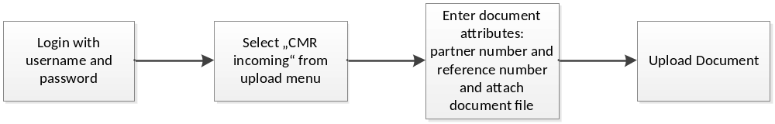  The user has to log in with his user name and password.  The user has to select „CMR incoming“ from upload menu and the page to upload „CMR (incoming)“-documents will open.  The user must enter search attributes:  - Partner number (mandatory)  - Reference number (mandatory)  The user must attach the document file itself to upload the document.  Upload: Air waybill  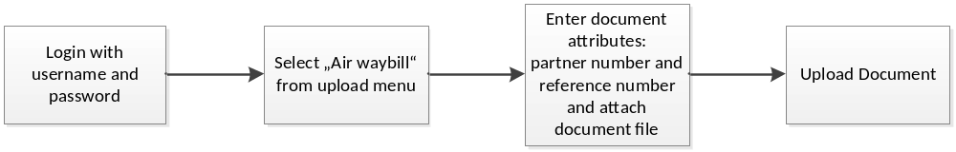  The user has to log in with his user name and password.  The user has to select „Air waybill“ from upload menu and the page to upload „Air waybill“-documents will open.  The user must enter search attributes:  - Partner number (mandatory)  - Reference number (mandatory)  The user must attach the document file itself to upload the document.  Upload: Bill of Lading  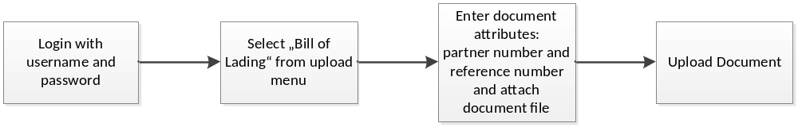  The user has to log in with his user name and password.  The user has to select „Bill of lading“ from upload menu and the page to upload „Bill of lading“-documents will open.  The user must enter search attributes:  - Partner number (mandatory)  - Reference number (mandatory)  The user must attach the document file itself to upload the document.  Carrier  Download: Air waybill  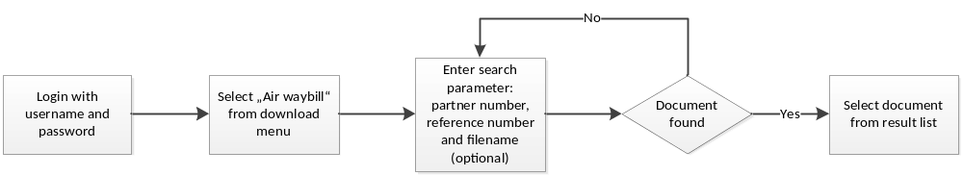  The user has to log in with his user name and password.  The user has to select „Air waybill“ from download menu and the page to search for „Air waybill“-documents will open.  The user can enter search parameter:  - Partner number (mandatory)  - Reference number (mandatory)  - Filename (optional)  The result of search will be displayed in a list and the user can download a document from the list.  Download: Bill of Lading  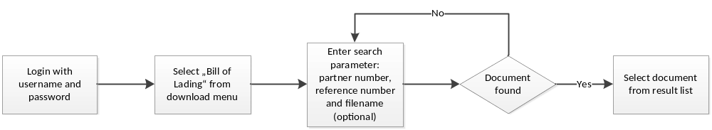  The user has to log in with his user name and password.  The user has to select „Bill of Lading“ from download menu and the page to search for „Bill of Lading“-documents will open.  The user can enter search parameter:  - Partner number (mandatory)  - Reference number (mandatory)  - Filename (optional)  The result of search will be displayed in a list and the user can download a document from the list.  Download: Shippers declaration  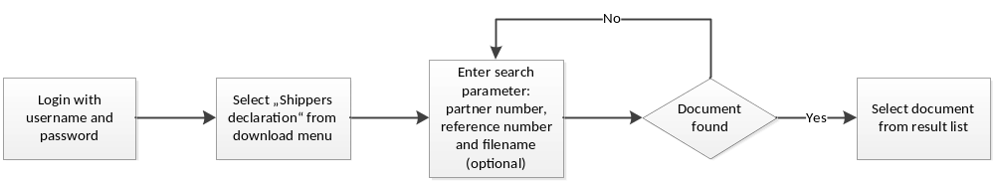  The user has to log in with his user name and password.  The user has to select „Shippers declaration“ from download menu and the page to search for „Shippers declaration“-documents will open.  The user can enter search parameter:  - Partner number (mandatory)  - Reference number (mandatory)  - Filename (optional)  The result of search will be displayed in a list and the user can download a document from the list.  Download: Waybill  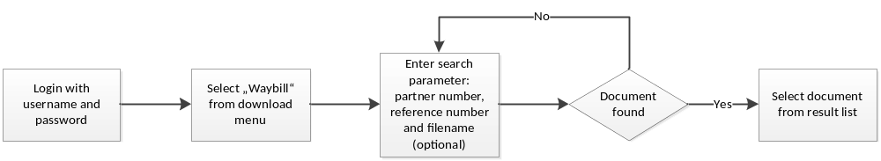  The user has to log in with his user name and password.  The user has to select „Waybill“ from download menu and the page to search for „Waybill“-documents will open.  The user can enter search parameter:  - Partner number (mandatory)  - Reference number (mandatory)  - Filename (optional)  The result of search will be displayed in a list and the user can download a document from the list.  Download: FDA certificate  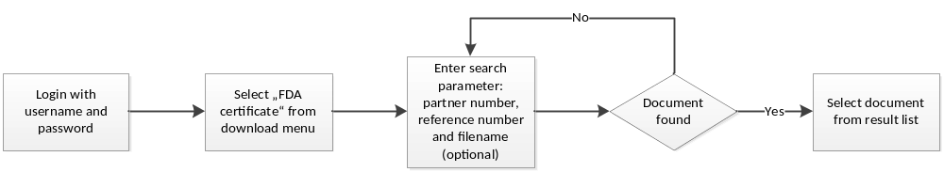  The user has to log in with his user name and password.  The user has to select „FDA certificate“ from download menu and the page to search for „FDA certificate“-documents will open.  The user can enter search parameter:  - Partner number (mandatory)  - Reference number (mandatory)  - Filename (optional)  The result of search will be displayed in a list and the user can download a document from the list.  Download: CMR (outgoing)  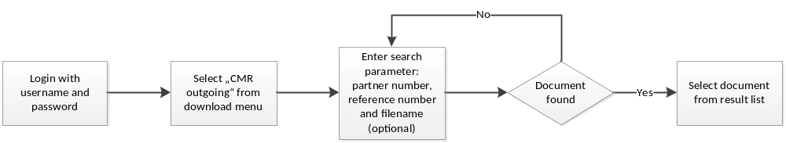  The user has to log in with his user name and password.  The user has to select „CMR outgoing“ from download menu and the page to search for „CMR outgoing“-documents will open.  The user can enter search parameter:  - Partner number (mandatory)  - Reference number (mandatory)  - Filename (optional)  The result of search will be displayed in a list and the user can download a document from the list.  Customs Broker  Download: Air waybill    The user gets a direct link to a document. After clicking on the link the user has to log in with his user name and password. He can download the document directly than.  Download: Bill of Lading  The user gets a direct link to a document. After clicking on the link the user has to log in with his user name and password. He can download the document directly than.  Download: Shippers declaration  The user gets a direct link to a document. After clicking on the link the user has to log in with his user name and password. He can download the document directly than.  Download: Waybill  The user gets a direct link to a document. After clicking on the link the user has to log in with his user name and password. He can download the document directly than.  Download: FDA certificate  The user gets a direct link to a document. After clicking on the link the user has to log in with his user name and password. He can download the document directly than.
1) | S | Requirement is covered by SAP standard
 | C | Requirement can be covered by system parameterization / customizing
 | D | Requirement can be covered by customer-specific development
 | A | Requirement can be covered by authorization management
 | SOP | Requirement can not be covered by the system. Therefore an SOP is needed
 | M | Requirement can be covered by master data maintenance
 | N | Requirement will not be realized

Reference to Configuration Documents / Customizing Objects
It is recommended to fill in the corresponding customizing objects in the following table.

IMG Customizing Objects | IMG Object Text | Type²⁾ of Customizing Object (V/C/T)
N/A

2) | C | Viewcluster
 | L | Logical transport object
 | S | Table (with text table)
 | T | Individual transaction object
 | V | View
 | D | Dummy object

Attachments
Please list here all attachments to this document. Fill in N/A if the document has no attachments

N/A

Further Information
Please use this section to add information that does not fit in any of the other sections. Use it especially to add complex details (e.g. tables) which do not have enough room in the functional realization table.
Do NOT put information in here, which will be already covered in further documentation as the Design Specification for Developments or the Configuration Documents.
Fill in N/A if the document has no further information.

N/A

